Granger Causality Test
Given the past values of variable Y, if the past values of variable X are useful for predicting Y, variable X is said to Granger cause variable Y.
Basic Approach
- Regressing Y on its own lagged values and on lagged values of X
- Testing of the null hypothesis that the coefficients of the lagged values of X are jointly zero (Restricted F Test) - Rejection of the null hypothesis implies X Granger causes Y
Basic Equations
- 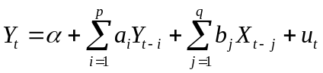
- 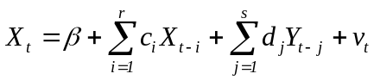
Four Possible Cases:
    - Unidirectional causality from X to Y: If at least one of the coefficients of lagged X in the first equation are statistically significant (the null hypothesis of the restricted F Test is rejected), whereas those of lagged Y are not as a group in the second equation (the null hypothesis of the restricted F Test is not rejected)

    - Unidirectional causality from Y to X: If at least one of the coefficients of lagged Y in the second equation are statistically significant (the null hypothesis of the restricted F Test is rejected), whereas those of lagged X are not as a group in the first equation ((the null hypothesis of the restricted F Test is not rejected)

    - Feedback or bilateral causality: If the coefficients of both lagged X and lagged Y are statistically significant in both the equations (when the coefficients are statistically significant in both the equations)

    - Independence: If the coefficients of both lagged X and lagged Y are not statistically significant in both the equations (when the coefficients are not statistically significant in either of the equations)
Decision Matrix on Granger Causality
 | Fail to Reject:  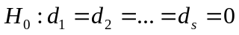 | Reject:
Fail to Reject:  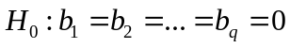 | No Granger causality either from X to Y or from Y to X | Unidirectional Granger causality from Y to X
Reject: | Unidirectional Granger causality from X to Y | Bidirectional Granger causality between X and Y

Decision Matrix on Feedback Effects
 | Fail to Reject:  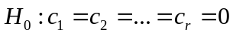 | Reject:
Fail to Reject:  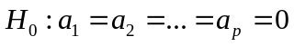 | No feedback effect either for X or for Y | Feedback effect only for X
Reject: | Feedback effect only for Y | Feedback effect for both X and Y

Steps in Granger Causality Test
- Regressing current Y on lagged Y, but without inclusion of X – Restricted RSS
- Regressing current Y on both lagged Y and on lagged X – Unrestricted RSS
- H₀: Lagged X terms do not influence Y
- Carrying out restricted F test
- Rejection of the H₀ – X Granger causes Y
- Repetition of steps to test if Y Granger causes X
Major Concerns in Granger Causality Test
- Non-stationary nature of the variables
- Lag length influencing the direction of causality
- Autocorrelated error terms in the two equations

reg save_con L(1/1).save_con L(1/1).gdp_con
reg gdp_con L(1/1).gdp_con L(1/1).save_con
var save_con gdp_con, lag(1/1)
vargranger
var save_con gdp_con, lag(1/1) dfk small
vargranger

